PRODUCT NEWS

Marketing contact: Birgit Radlinger
bradlinger@isravision.com
Revealing hidden potential with EPROMI – the production management intelligence tool from ISRA VISION
With its EPROMI production management intelligence tool, ISRA VISION (www.isravision.de) now offers a powerful add-on for its inline inspection solutions for the print industry. As well as displaying and analyzing real-time data for end-to-end process monitoring, its key advantage is enabling collected inspection and production data to be comprehensively evaluated. This reveals hidden potential and provides a basis for informed decision-making to optimize product portfolios, continuously improve process efficiency and quality, and maximize profitability.

Nowadays, state-of-the-art production systems, quality assurance systems and reporting tools generate vast quantities of data, which – when correlated effectively – can provide valuable information for economic decisions throughout the value chain. ISRA VISION’s EPROMI production analytics platform allows this data to be evaluated comprehensively based on various KPIs. Having already proven its value in other sectors, including film extrusion and the manufacturing of unprinted packaging materials/films, it is now also available for the company’s print inspection solutions.

EPROMI contains live dashboards for monitoring inspection systems, production lines and current product quality in real time, keeping production and quality managers informed about the print job in question. Customizable threshold values and alarms help users to identify and resolve issues quickly. This allows a rapid response in the event of production defects, reducing downtimes and lowering production costs by extension.

EPROMI’s analytical dashboards are used to present a clear overview and analyze historical data from previous production jobs. By intelligently aggregating the information captured by the inspection systems and the production lines, trends in the manufacturing process can be identified and specific patterns recognized, enabling appropriate actions to be taken as necessary. To this end, the tool can help optimize operational procedures and production processes to prevent defects, reduce material consumption, lower costs and further enhance product quality.

EPROMI can be installed either on a physical or virtual server that is integrated in the customer’s IT landscape, or in the customer’s existing cloud. Its standardized interfaces also mean that data from third-party tools and sensors can be seamlessly integrated into the platform. Data is accessible from anywhere and using any end device thanks to an intuitive web browser interface.

Further information about EPROMI is available online at: https://go.isravision.com/epromi-product-news

ISRA VISION is a leading provider of technologies for industrial image processing (machine vision). As part of the Atlas Copco Group, a globally leading provider of sustainable productivity solutions, we offer an extensive range of solutions for surface inspection, robot guidance and automated measurement technology. Employing around 1,200 people, we supply customers in 16 markets and in a wide range of industries. We are based in Darmstadt, Germany, and offer our customers added value through an agile global organization under the brands ISRA VISION, Perceptron and QUISS.

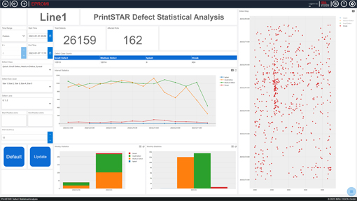
EPROMI allows users to identify defect and production trends. The corresponding dashboards reveal defect patterns and provide the basis for any ensuing process optimizations.

