PRODUCT NEWS

Media Contact: Birgit Radlinger
bradlinger@isravision.com
ISRA VISION presents DecoSTAR EVO – the new generation of its inline print inspection solution for metal sheets
ISRA VISION (www.isravision.com) has completely revised its proven DecoSTAR solution for the inline inspection of decorated metal sheets. The new version DecoSTAR EVO comes with an enhanced inspection performance for offset printing and enables the inspection of digitally decorated tin and aluminum sheets for packaging applications such as food cans, decorative boxes, or oil cans. DecoSTAR EVO not only features an advanced defect classifier for uncomplicated, fast system set-up and start-up, as well as a modern, intuitive graphical user interface but is also equipped with the company's latest high-performance lighting and camera technology. An integrated interface to the optionally available production management intelligence tool EPROMI completes the package.

High quality at high production speed – these are the prerequisites for the cost-efficient production of printed metal sheets for packaging applications. The DecoSTAR inline inspection system from ISRA VISION enables reliable quality control when decorating steel or aluminum sheets and has been used in the industry for many years. The flexible system is suitable for tinplate or aluminum as well as for high-gloss or matt motifs on any type of machine. Thanks to highly efficient LED lighting and a high-resolution, high-tech camera, the system can reliably detect typical defects such as color deviations, hickeys, stripes, streaks, or edge and material defects. It also provides high-quality defect data that helps to eliminate serial defects and reduce rejects.

New in DecoSTAR EVO is the support for digital printing. The system detects relevant defects such as splashes, streaks, and smears caused by clogged nozzles on digitally printed metal sheets. ISRA VISION thus combines offset and digital print inspection in a single system and offers its customers more flexibility in application.

Also new is the self-learning defect classifier already known from the company's other inline inspection solutions. It allows to define customized guidelines and tolerances for each print job in order to distinguish between 'relevant' and 'non-relevant' defects. For this purpose, precise details of the defects to be detected as well as limit values are entered in the defect classifier in a job-specific profile. In line with this, faulty prints are either sorted out automatically or the operator receives an alarm so that he can intervene in the printing process accordingly. Non-relevant defects are nevertheless recorded and can be found in the inspection report with exact position information. This helps to avoid waste, increase the saleable quantity, and reduce costs.

Thanks to state-of-the-art LED lighting and high-resolution camera technology, DecoSTAR EVO is able to detect defects of 50 µm. In addition, the revised modern graphical user interface ensures intuitive and easy operation. The newly integrated EPROMI interface enables connection to the optionally available Production Management Intelligence Tool from ISRA VISION. This allows the extensive recorded data on the inspection system and production to be put into relation and comprehensively analyzed. Based on these evaluations, appropriate measures can then be derived that can contribute to the improvement of processes and results.

For more information, please go to: https://www.isravision.com/en-en/industries/print/metal-sheet-decoration

ISRA VISION is a leading provider of industrial image processing technologies with more than 1,200 employees across 25 locations worldwide. As part of the Machine Vision division of the Atlas Copco Group, a world-leading provider of sustainable productivity applications, we provide innovative and intelligent industrial solutions ranging from surface inspection to software-controlled robotics systems for smart factory automation. We have been driven by passion, commitment, and diversity for over 35 years.

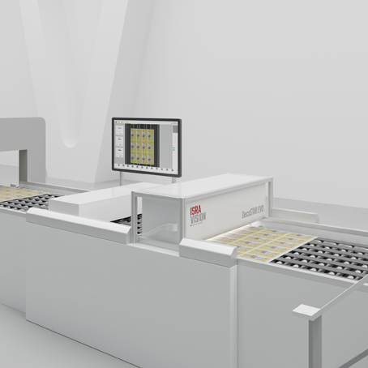

ISRA VISION (www.isravision.com) has completely revised its proven DecoSTAR solution for the inline inspection of decorated metal sheets. The new version DecoSTAR EVO comes with an enhanced inspection performance for offset printing and enables the inspection of digitally decorated tin and aluminum sheets for packaging applications.

